Functional Models – “PyTCG-Eval: Automated Python Test Case Generation and Evaluation System”
Binita Chourasia, Systems Analyst
February 10, 2026

- Use Case Diagram
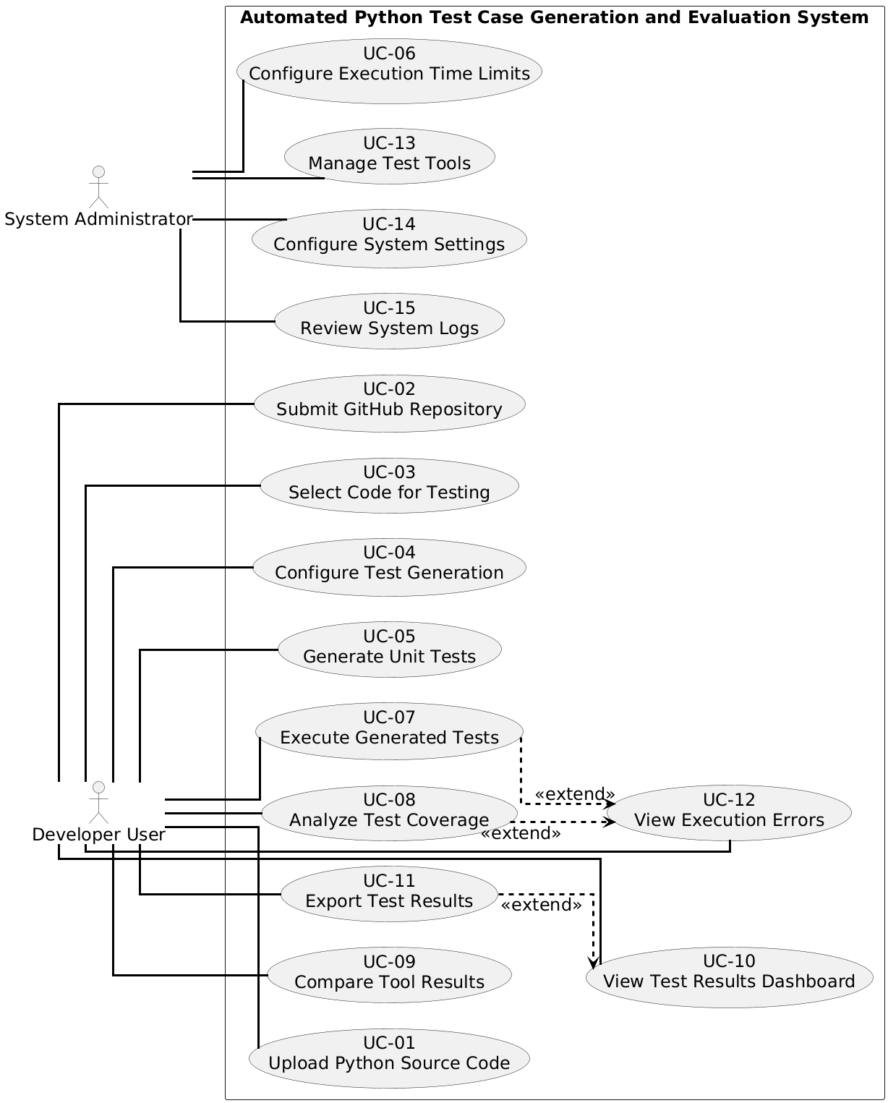

Diagram 1: Use Case Diagram for “Automated Python Test Case Generation and Evaluation System”
- Use Case Description
Use Case - 1
Use Case Name: Upload Python Source Code |  | ID:UC-1 | Importance Level: High
Primary Actor: Developer User | Use Case Type: User Goal
Stakeholders and Interests: Developer User wants to provide Python source code files easily so that automated tests can be generated.
The system requires valid Python files to process and prepare them for subsequent analysis.
Brief Description: This use case allows a Developer User to upload one or more Python source code files into the system. The system validates the files and makes them available for selection in subsequent test generation steps.
Trigger: The Developer initiates the upload by selecting files and clicking the “Upload” button.
Type: User Action
Relationships:
Association: Developer User
Include: None
Extend: None
Generalization: None
Normal Flow of Events:
- Developer navigates to the “Upload” section of the application.
- Developer clicks the “Upload Files” button.
- Developer selects one or more .py files from local storage.
- System validates each selected file to ensure it is a Python source file.
- System confirms successful upload and lists all uploaded files in the project workspace.
SubFlows: S-1: If the Developer selects multiple files, the system processes each file sequentially and reports any issues for each file individually.
Alternate/Exceptional Flows:
Invalid File Type: If a file is not a Python file, the system displays: “Only .py files are allowed.” The Developer re-selects valid files before uploading again.
Upload Failure: If a file cannot be read due to permission issues or corruption, the system displays: “File could not be uploaded.” The Developer can retry or cancel.
No Files Selected: If the Developer clicks “Upload” without selecting any files, the system displays: “Please select at least one Python file to upload,” and waits for the user to choose files.

This use case addresses the following system requirements: 1.

Use Case - 2
Use Case Name: Submit GitHub Repository |  | ID:UC-2 | Importance Level: High
Primary Actor: Developer User | Use Case Type: User Goal
Stakeholders and Interests: The Developer User wants to submit a GitHub repository URL so that the system can automatically access and analyze the Python source code. The system requires a valid repository link to fetch the source code for test generation and subsequent coverage analysis.
Brief Description: This use case allows a Developer User to provide a public GitHub repository URL. The system verifies the repository, retrieves the Python source code, and prepares it for selection in subsequent test generation steps.
Trigger: The Developer initiates the submission by entering a repository URL and clicking the “Submit” button.
Type: User Action
Relationships:
Association: Developer User
Include: None
Extend: None
Generalization: None
Normal Flow of Events:
- Developer navigates to the “Submit Repository” section of the application.
- Developer enters a valid GitHub repository URL into the provided input field.
- Developer clicks the “Submit” button.
- System verifies that the URL points to a public GitHub repository.
- System retrieves all Python source files from the repository.
- System confirms successful retrieval and lists the files in the project workspace for further selection.
SubFlows:
S-1: If the repository contains multiple Python modules or directories, the system fetches each module sequentially and organizes them for selection in the project workspace.
Alternate/Exceptional Flows:
Invalid Repository URL: If the URL is not a valid GitHub repository, the system displays: “Invalid repository URL. Please enter a valid public GitHub repository.” The Developer re-enters a correct URL before submitting again.
Access Failure: If the repository is private, unavailable, or network issues prevent fetching, the system displays: “Repository could not be accessed. Check permissions or network connection.” The Developer may retry submission or cancel.
No URL Entered: If the Developer clicks “Submit” without entering any URL, the system displays: “Please enter a GitHub repository URL,” and waits for the Developer to provide one.

This use case addresses the following system requirements: 2.
Use Case - 3
Use Case Name: Select Code for Testing |  | ID:UC-3 | Importance Level: High
Primary Actor: Developer User | Use Case Type: User Goal
Stakeholders and Interests:
The Developer User wants to select specific Python files or modules from the uploaded files or retrieved GitHub repository to focus test generation on the relevant parts of the code. The system needs this selection to know which files to process for automated unit test generation.
Brief Description: This use case allows the Developer User to choose one or more Python source files or modules from previously uploaded files or retrieved GitHub repositories. The system highlights the selected files and prepares them for test generation in subsequent steps.
Trigger: The Developer navigates to the project workspace and selects the desired Python files or modules to include in test generation.
Type: User Action
Relationships:
Association: Developer User
Include: None
Extend: None
Generalization: None
Normal Flow of Events:
- Developer navigates to the project workspace containing uploaded files or retrieved repository code.
- Developer reviews the list of available Python source files and modules.
- Developer selects one or more files or modules for testing using checkboxes or a selection interface.
- System marks the selected files and updates the workspace to reflect the selection.
- System confirms the selected files are ready for test generation in the next use case.
SubFlows: S-1: If the Developer selects multiple modules or directories, the system processes each selection sequentially and validates that they are Python source files.
Alternate/Exceptional Flows: No Files Selected: If the Developer attempts to proceed without selecting any files, the system displays: “Please select at least one Python file or module to continue,” and waits for the user to make a selection.
Invalid Selection: If the Developer selects a file that is not a valid Python source file due to corruption or unsupported type, the system displays: “Selected file is not a valid Python file” and prompts the Developer to re-select valid files.
File Removed During Selection: If a previously uploaded or retrieved file is deleted or becomes unavailable during selection, the system notifies the Developer: “Selected file is no longer available,” and requires them to adjust the selection.
This use case addresses the following system requirements: 3.
Use Case - 4
Use Case Name: Configure Test Generation |  | ID:UC-4 | Importance Level: High
Primary Actor: Developer User | Use Case Type: User Goal
Stakeholders and Interests: The Developer User wants to configure the automated test generation process by selecting which tools to use and setting parameters such as execution time limits. The system requires these settings to run test generation correctly and provide meaningful results.
Brief Description: This use case allows the Developer User to select one or more automated test generation tools, configure parameters, and prepare the system for running test generation on selected Python files or modules.
Trigger: The Developer initiates configuration by navigating to the test generation settings and specifying tool choices and parameters.
Type: User Action
Relationships:
Association: Developer User
Include: None
Extend: None
Generalization: None
Normal Flow of Events:
- Developer navigates to the “Configure Test Generation” section of the system.
- Developer selects one or more automated test generation tools from the available options (e.g., Pynguin, Hypothesis, UTBotPython).
- Developer sets parameters, such as maximum execution time or specific modules to target.
- Developer reviews the configuration and confirms the selections.
- System saves the configuration and marks it as ready for the Generate Unit Tests use case.
SubFlows:
S-1: If the Developer selects multiple tools, the system saves the configuration for each tool and ensures all selected tools are properly initialized before running test generation.
Alternate/Exceptional Flows:
No Tools Selected: If the Developer attempts to proceed without selecting any tools, the system displays: “Please select at least one test generation tool” and waits for the user to make a selection.
Invalid Parameters: If any configured parameter is invalid, such as negative execution time, the system displays: “Invalid parameter value” and prompts the Developer to correct it.
Configuration Save Failure: If the system cannot save the configuration due to an internal error, it notifies the Developer: “Configuration could not be saved. Please try again,” allowing them to retry.

This use case addresses the following system requirements: 4, 5, 17.
Use Case - 5
Use Case Name: Generate Unit Tests |  | ID:UC-5 | Importance Level: High
Primary Actor: Developer User | Use Case Type: User Goal
Stakeholders and Interests: The Developer User wants to automatically generate unit tests for the selected Python files or modules using one or more automated test generation tools. The system must generate tests efficiently, enforce user-defined settings, and make results available for subsequent evaluation.
Brief Description: This use case allows the Developer User to run the automated test generation process. The system executes the selected tools on the chosen Python files or modules and prepares the generated tests for execution and coverage analysis.
Trigger: The Developer initiates test generation by clicking the “Generate Unit Tests” button after configuring the tools and selecting files.
Type: User Action
Relationships:
Association: Developer User
Include: None
Extend: UC-12 View Execution Errors
Generalization: None
Normal Flow of Events:
- Developer navigates to the “Generate Unit Tests” section of the system.
- Developer confirms the configuration and selected files for test generation.
- Developer clicks the “Generate Unit Tests” button.
- System sequentially executes each selected test generation tool on the chosen files or modules.
- System saves all generated test files in the project workspace and updates the workspace to show the new tests.
- System confirms successful completion of the test generation process.
SubFlows:
S-1: If multiple test generation tools are selected, the system executes them one after another and records the results for each tool separately.
Alternate/Exceptional Flows:
Tool Execution Failure: If a selected tool fails during execution, the system logs the error and continues with the remaining tools. This flow extends to UC-12: View Execution Errors, allowing the Developer to review the failure details.
No Files Selected: If no files were selected for test generation, the system displays: “Please select files or modules to generate tests” and waits for the Developer to make a selection.
Configuration Missing: If the Developer attempts to generate tests without configuring the tools, the system displays: “Please configure test generation tools before proceeding” and prompts the user to configure the settings.
This use case addresses the following system requirements: 6, 7, 16, 25, 26, 29.
Use Case - 6
Use Case Name: Configure Execution Time Limits |  | ID:UC-6 | Importance Level: Medium
Primary Actor: System Administrator | Use Case Type: User Goal
Stakeholders and Interests: The System Administrator wants to set maximum execution time limits for each test generation tool to ensure that automated testing does not exceed acceptable runtime and system resources. The system needs these limits to control the behavior of test generation and prevent runaway executions.
Brief Description: This use case allows the System Administrator to configure execution time limits for each automated test generation tool. The system saves these limits, which are then enforced automatically during test generation without further user intervention.
Trigger: The System Administrator initiates the configuration by navigating to the system settings and specifying execution time limits for each tool.
Type: User Action
Relationships:
Association: System Administrator
Include: None
Extend: None
Generalization: None
Normal Flow of Events:
- System Administrator navigates to the “System Settings” or “Test Tool Configuration” section.
- System displays a list of available test generation tools with current execution time limits.
- System Administrator reviews the tools and selects one or more to configure.
- System Administrator sets or updates the maximum execution time for each selected tool.
- System validates the input to ensure all time limits are positive and reasonable.
- System saves the updated configuration and confirms the changes.
SubFlows:
S-1: If multiple tools are being configured, the system validates and saves each tool’s limit sequentially and reports any issues individually.
Alternate/Exceptional Flows:
Invalid Time Limit: If the System Administrator enters a negative or zero value for a time limit, the system displays: “Invalid execution time. Please enter a positive number” and prompts for correction.
Save Failure: If the system cannot save the configuration due to an internal error, it displays: “Execution time limits could not be saved. Please try again,” allowing the Administrator to retry.
No Tool Selected: If the Administrator attempts to save without selecting any tool, the system displays: “Please select at least one tool to configure execution time limits” and waits for a selection.
This use case addresses the following system requirements: 5, 31.
Use Case - 7
Use Case Name: Execute Generated Tests |  | ID:UC-7 | Importance Level: High
Primary Actor: Developer User | Use Case Type: User Goal
Stakeholders and Interests: The Developer User wants to run the generated unit tests against the selected Python source code to verify correctness. The system must execute the tests efficiently and record results so that coverage and evaluation can be performed in subsequent steps.
Brief Description: This use case allows the Developer User to execute all generated unit tests for the selected Python files or modules. The system runs each test, records results, and reports any execution errors for optional review.
Trigger: The Developer initiates test execution by clicking the “Run Tests” button in the project workspace.
Type: User Action
Relationships:
Association: Developer User
Include: None
Extend: UC-12 View Execution Errors
Generalization: None
Normal Flow of Events:
- Developer navigates to the “Execute Tests” section of the system.
- Developer selects the tests or test suites to execute.
- Developer clicks the “Run Tests” button.
- System sequentially executes each selected test case against the chosen Python files or modules.
- System records test results, including pass/fail status and runtime information.
- System updates the project workspace to reflect completed execution and results.
SubFlows:
S-1: If multiple test suites are selected, the system executes them sequentially and stores results separately for each suite.
Alternate/Exceptional Flows:
Test Execution Failure: If a test fails due to runtime errors or unexpected exceptions, the system logs the details and extends to UC-12: View Execution Errors, allowing the Developer to review and analyze the issues.
No Tests Selected: If the Developer clicks “Run Tests” without selecting any tests, the system displays: “Please select at least one test to execute” and waits for the user to make a selection.
Environment Failure: If a test cannot run due to missing dependencies or system resource issues, the system displays: “Test execution failed due to environment issues,” and the Developer may retry after resolving the issue.
This use case addresses the following system requirements: 8, 16, 26.
Use Case - 8
Use Case Name: Analyze Test Coverage |  | ID:UC-8 | Importance Level: High
Primary Actor: Developer User | Use Case Type: User Goal
Stakeholders and Interests: The Developer User wants to analyze the effectiveness of generated unit tests by measuring line coverage, branch coverage, and mutation coverage. The system must calculate these metrics accurately and present results to help identify areas that need additional testing.
Brief Description: This use case allows the Developer User to run coverage analysis on executed tests. The system evaluates the test suites against the selected Python files or modules, calculates coverage metrics, and stores the results for comparison and reporting.
Trigger: The Developer initiates coverage analysis by clicking the “Analyze Coverage” button after executing tests.
Type: User Action
Relationships:
Association: Developer User
Include: None
Extend: UC-12 View Execution Errors
Generalization: None
Normal Flow of Events:
- Developer navigates to the “Coverage Analysis” section of the system.
- Developer selects the executed test runs to analyze.
- Developer clicks the “Analyze Coverage” button.
- System calculates line coverage, branch coverage, and mutation coverage for the selected test runs.
- System stores the coverage results and updates the project workspace to display summaries and metrics.
- System confirms completion of the coverage analysis process.
SubFlows: S-1: If multiple test runs are selected, the system processes each run sequentially and records coverage metrics separately for each run.
Alternate/Exceptional Flows:
Execution Error Detected: If a test run fails or produces errors during coverage analysis, the system logs the issue and extends to UC-12: View Execution Errors, allowing the Developer to review error details.
No Test Runs Selected: If the Developer clicks “Analyze Coverage” without selecting any test runs, the system displays: “Please select at least one executed test run to analyze” and waits for a selection.
Invalid Test Data: If the selected test run data is corrupted or missing, the system displays: “Coverage analysis cannot proceed due to invalid test data,” and the Developer may choose another test run.
This use case addresses the following system requirements: 9, 10, 11, 12, 13, 15, 27, 28.
Use Case - 9
Use Case Name: Compare Tool Results |  | ID:UC-9 | Importance Level: High
Primary Actor: Developer User | Use Case Type: User Goal
Stakeholders and Interests: The Developer User wants to compare the results of different automated test generation tools to determine which tool provides the most effective coverage for the selected Python files. The system must present the results in a clear, organized manner to support informed decisions about tool selection and test quality.
Brief Description: This use case allows the Developer User to select multiple test generation tool results and compare their coverage metrics and test effectiveness. The system calculates comparative statistics and displays them in a structured format within the project workspace or dashboard.
Trigger: The Developer initiates comparison by clicking the “Compare Tool Results” button after one or more coverage analyses have been completed.
Type: User Action
Relationships:
Association: Developer User
Include: None
Extend: None
Generalization: None
Normal Flow of Events:
- Developer navigates to the “Compare Tool Results” section of the system.
- Developer selects two or more completed test generation tool runs to compare.
- Developer clicks the “Compare Tool Results” button.
- System retrieves the coverage metrics and test execution results for each selected tool run.
- System calculates comparative metrics, such as total coverage percentages, number of tests generated, and mutation coverage.
- System displays the comparison in a structured table or chart within the dashboard.
- Developer reviews the comparison to evaluate tool performance and effectiveness.
SubFlows:
S-1: If multiple projects or multiple code modules are selected for comparison, the system calculates metrics for each project or module individually and aggregates results for the overall comparison.
Alternate/Exceptional Flows:
No Tool Results Selected: If the Developer clicks “Compare Tool Results” without selecting any tool runs, the system displays: “Please select at least two tool results to compare” and waits for the user to make a selection.
Incomplete Coverage Data: If a selected tool run does not have complete coverage results, the system displays: “Comparison cannot be performed due to incomplete data” and allows the Developer to select other tool runs.
This use case addresses the following system requirements: 12, 14, 29.
Use Case - 10
Use Case Name: View Test Results Dashboard |  | ID:UC-10 | Importance Level: High
Primary Actor: Developer User | Use Case Type: User Goal
Stakeholders and Interests: The Developer User wants to review the results of executed tests and coverage analyses in a centralized dashboard. The system must present the test outcomes, coverage metrics, and tool performance clearly to help the Developer evaluate code quality and guide further testing.
Brief Description: This use case allows the Developer User to access a dashboard that consolidates test execution results, coverage metrics, and tool comparisons. The system displays detailed summaries, historical results, and links to generated test files for each test run.
Trigger: The Developer navigates to the “Test Results Dashboard” to review completed test executions and coverage analyses.
Type: User Action
Relationships:
Association: Developer User
Include: None
Extend: None
Generalization: None
Normal Flow of Events:
- Developer navigates to the “Test Results Dashboard” section of the system.
- System retrieves all relevant test execution and coverage analysis results for the selected project.
- System displays a summary of test runs, including total tests executed, passed, failed, and coverage percentages.
- System allows the Developer to filter results by test generation tool, date, or project.
- Developer selects specific test runs to view detailed results, including generated test files, coverage metrics, and execution logs.
- System updates the dashboard to reflect any newly executed tests or analyses.
SubFlows: S-1: If multiple projects or multiple test runs are selected, the system aggregates results and presents comparisons across projects or runs.
Alternate/Exceptional Flows:
No Test Results Available: If there are no executed test runs for the selected project, the system displays: “No test results available. Please generate and execute tests first” and waits for the Developer to perform test generation and execution.
Data Retrieval Failure: If the system cannot retrieve stored results due to file corruption or read errors, the system displays: “Cannot display dashboard due to data retrieval error” and prompts the Developer to retry or select another project.

This use case addresses the following system requirements: 13, 20, 21, 22, 30, 28.
Use Case - 11
Use Case Name: Export Test Results |  | ID:UC-11 | Importance Level: Medium
Primary Actor: Developer User | Use Case Type: User Goal
Stakeholders and Interests: The Developer User wants to export test execution and coverage results to share with team members, document project progress, or store results externally. The system must generate accurate CSV or PDF files that reflect the data shown in the test results dashboard.
Brief Description: This use case allows the Developer User to export selected test results and coverage metrics from the dashboard into CSV or PDF formats. The system formats the data correctly and saves the files to the user-specified location.
Trigger: The Developer initiates export by clicking the “Export Results” button in the test results dashboard.
Type: User Action
Relationships:
Association: Developer User
Include: None
Extend: UC-10 View Test Results Dashboard
Generalization: None
Normal Flow of Events:
- Developer navigates to the “Test Results Dashboard.”
- Developer selects one or more test runs or coverage analyses to export.
- Developer clicks the “Export Results” button.
- System prompts the Developer to choose the export format: CSV or PDF.
- Developer selects the desired format and destination folder.
- System formats the selected results and generates the export file.
- System confirms successful export and provides the file location.
SubFlows: S-1: If multiple test runs are selected for export, the system generates separate files for each run or a combined file, depending on the Developer’s choice.
Alternate/Exceptional Flows:
No Test Runs Selected: If the Developer clicks “Export Results” without selecting any test runs, the system displays: “Please select at least one test run to export” and waits for a selection.
Export Failure: If the system cannot write the file due to permission issues or disk errors, it displays: “Export failed. Please check the file location and permissions” and allows the Developer to retry.
This use case addresses the following system requirements: 23, 24.
Use Case – 12
Use Case Name: View Execution Errors |  | ID:UC-12 | Importance Level: High
Primary Actor: Developer User | Use Case Type: User Goal
Stakeholders and Interests: The Developer User wants to review detailed error messages when test execution or coverage analysis fails. The system must provide clear, actionable information so the Developer can identify and correct problems in the source code or test configurations.
Brief Description: This use case allows the Developer User to access and review execution errors generated during test execution or coverage analysis. The system displays error messages, stack traces, and links to affected files to support troubleshooting and correction.
Trigger: Errors are detected during test execution (UC-07) or coverage analysis (UC-08), prompting the system to allow the Developer to view details.
Type: System Event
Relationships:
Association: Developer User
Include: None
Extend: None
Generalization: None
Normal Flow of Events:
- System detects an error during test execution or coverage analysis.
- Developer navigates to the “Execution Errors” section of the system.
- System displays a list of all detected errors, including test names, affected Python files, and error messages.
- Developer selects a specific error to view detailed information, including stack traces and context.
- Developer uses the information to correct issues in the source code or test configurations.
- System allows the Developer to refresh the error list after making corrections and re-running tests or analyses.
SubFlows:
S-1: If multiple errors occur during a test run or coverage analysis, the system lists them sequentially and allows the Developer to select each error for detailed review.
Alternate/Exceptional Flows:
No Errors Detected: If there are no errors during execution or analysis, the system displays: “No execution errors detected” and returns the Developer to the previous dashboard view.
Data Retrieval Failure: If the system cannot access stored error logs due to file corruption or read issues, it displays: “Cannot retrieve execution errors” and allows the Developer to retry or select another test run.

This use case addresses the following system requirements: 18, 19.
Use Case - 13
Use Case Name: Manage Test Tools |  | ID:UC-13 | Importance Level: High
Primary Actor: System Administrator | Use Case Type: User Goal
Stakeholders and Interests: The System Administrator wants to enable or disable individual test generation tools and manage their configuration to ensure the system operates correctly and securely. The system must allow the Administrator to control tool availability and set tool-specific parameters for proper test generation.
Brief Description: This use case allows the System Administrator to manage the configuration and availability of automated test generation tools. The system provides an interface to enable or disable tools, configure execution parameters, and verify that tools are ready for Developer use.
Trigger: The System Administrator navigates to the “Manage Test Tools” section and initiates tool configuration or availability changes.
Type: User Action
Relationships:
Association: System Administrator
Include: None
Extend: None
Generalization: None
Normal Flow of Events:
- Administrator navigates to the “Manage Test Tools” section of the system.
- System displays a list of all supported test generation tools with current status and configuration parameters.
- Administrator selects a tool to enable, disable, or modify parameters.
- Administrator updates the tool’s execution parameters, such as maximum runtime, command-line options, or resource limits.
- System validates the updated configuration and confirms changes.
- Administrator repeats the process for other tools as needed.
- System saves all configuration changes to the system database for future use.
SubFlows:
S-1: If multiple tools are updated in a single session, the system processes each tool sequentially and validates configurations individually.
Alternate/Exceptional Flows:
Invalid Configuration: If the Administrator enters invalid parameters, the system displays: “Configuration error: please correct input values” and prevents saving until corrected.
Tool Update Failure: If the system cannot apply changes due to file access or internal errors, it displays: “Tool configuration update failed” and allows the Administrator to retry.

This use case addresses the following system requirements: 32, 33.
Use Case - 14
Use Case Name: Configure System Settings |  | ID:UC-14 | Importance Level: High
Primary Actor: System Administrator | Use Case Type: User Goal
Stakeholders and Interests: The System Administrator wants to configure system-wide settings, such as storage locations, coverage metric calculations, and safety restrictions, to ensure the system operates securely, reliably, and efficiently. The system must allow the Administrator to update these settings and apply them consistently across all operations.
Brief Description: This use case allows the System Administrator to configure global system settings that affect test execution, result storage, and safety restrictions. The system provides an interface to set parameters, enforce restrictions, and verify that the configuration changes are valid.
Trigger: The System Administrator navigates to the “Configure System Settings” section and initiates updates to system-wide parameters.
Type: User Action
Relationships:
Association: System Administrator
Include: None
Extend: None
Generalization: None
Normal Flow of Events:
- Administrator navigates to the “Configure System Settings” section.
- System displays current system-wide settings, including storage locations, coverage metric calculation options, and safety restrictions.
- Administrator selects settings to modify and enters new parameter values.
- System validates the inputs to ensure they are within acceptable ranges and meet security requirements.
- Administrator saves the updated settings.
- System applies the new configuration immediately or schedules changes for the next execution cycle.
- System confirms that all changes have been successfully applied.
SubFlows:
S-1: If multiple settings are updated in a single session, the system processes each setting sequentially and confirms application for each before moving to the next.
Alternate/Exceptional Flows:
Invalid Settings: If the Administrator enters invalid values, the system displays: “Invalid configuration. Please correct the values” and prevents saving until corrected.
Save Failure: If the system cannot save the new settings due to file or database errors, it displays: “System settings update failed” and allows the Administrator to retry.
This use case addresses the following system requirements: 34, 36, 37, 38, 39, 40.
Use Case - 15
Use Case Name: Review System Logs |  | ID:UC-15 | Importance Level: Medium
Primary Actor: System Administrator | Use Case Type: User Goal
Stakeholders and Interests: The System Administrator wants to review system logs to monitor system activity, troubleshoot errors, and ensure the integrity of test executions. The system must provide accurate and complete log information to help the Administrator identify issues and confirm proper operation.
Brief Description: This use case allows the System Administrator to access, filter, and review system-generated logs related to test generation, execution, coverage analysis, and other system operations. The system provides detailed information on actions performed, errors detected, and system events.
Trigger: The System Administrator navigates to the “System Logs” section to review recent activities or troubleshoot issues.
Type: User Action
Relationships:
Association: System Administrator
Include: None
Extend: None
Generalization: None
Normal Flow of Events:
- Administrator navigates to the “System Logs” section of the system.
- System displays a list of available log entries, including timestamps, actors, actions performed, and any errors detected.
- Administrator selects a specific log entry or time range to review in detail.
- System presents detailed information about the selected log entries, including associated files, test runs, or coverage analyses.
- Administrator analyzes the logs to identify potential issues, verify system behavior, or audit test executions.
- System allows the Administrator to filter logs by date, user, action type, or tool to simplify review.
SubFlows:
S-1: If multiple filters are applied, the system combines them sequentially and displays only log entries that meet all filter criteria.
Alternate/Exceptional Flows:
No Logs Available: If no logs exist for the selected criteria, the system displays: “No log entries available” and prompts the Administrator to select another time range or filter.
Log Retrieval Failure: If the system cannot access log files due to corruption or permission issues, it displays: “Unable to retrieve system logs” and allows the Administrator to retry.
This use case addresses the following system requirements: 35.
2. Activity Diagram
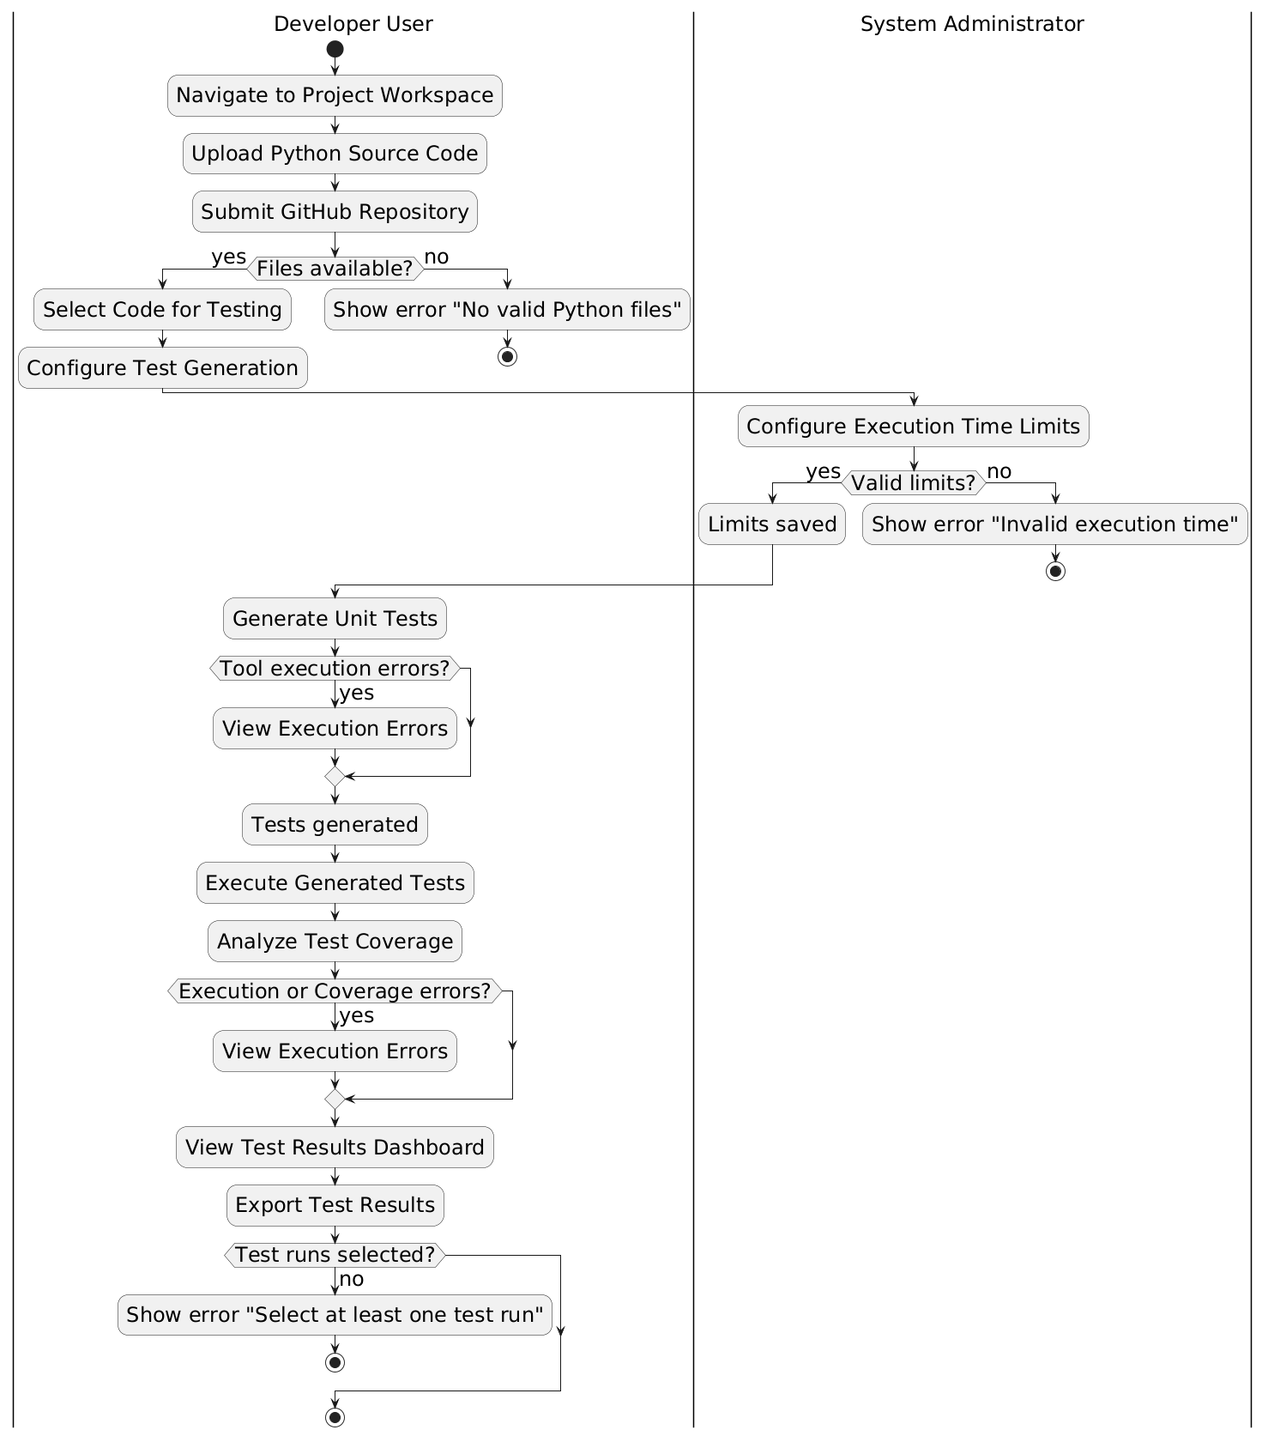
Diagram 3: Activity Diagram for “Automated Python Test Case Generation and Evaluation System”

